**DAY-2**

**3.** **Develop a system using UML for implementing the Exam R**

**AIM:-**

To develop a system using UML for EXAM REGISTRATION PORTAL.

UML DESIGNS:-

1.USECASE DIAGRAM:

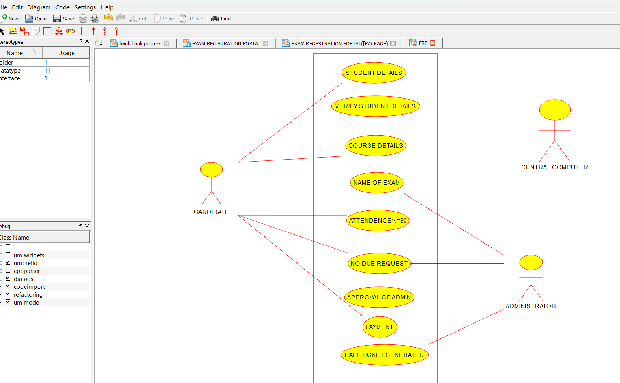

2.CLASS DIAGRAM:

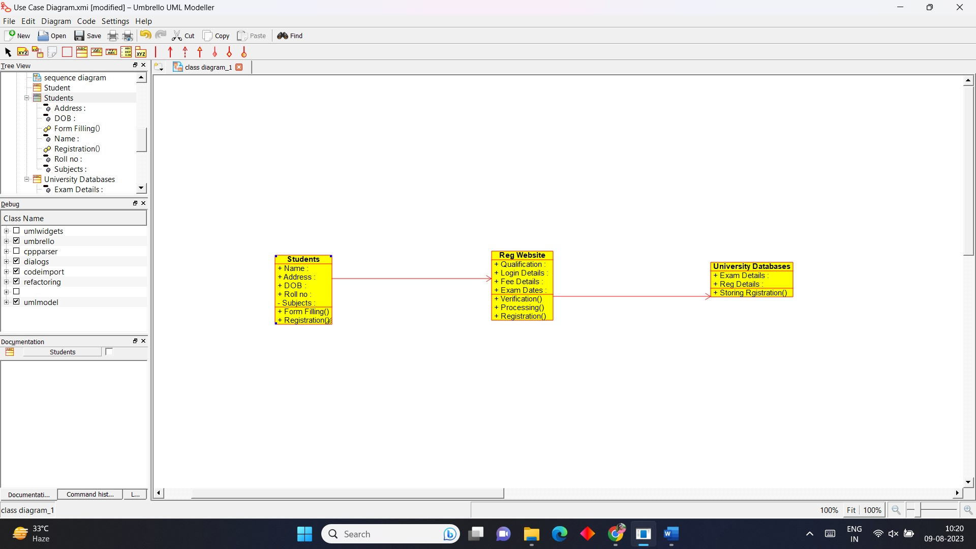

3.COMPONENT DIAGRAM: 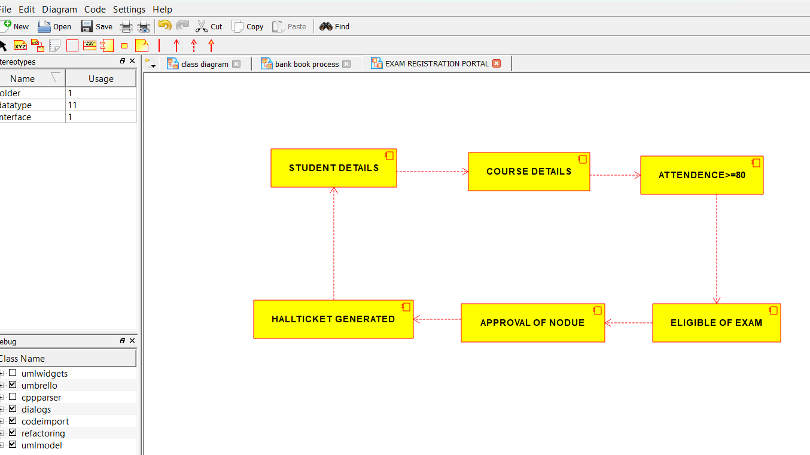

4.ACTIVITY DIAGRAM:

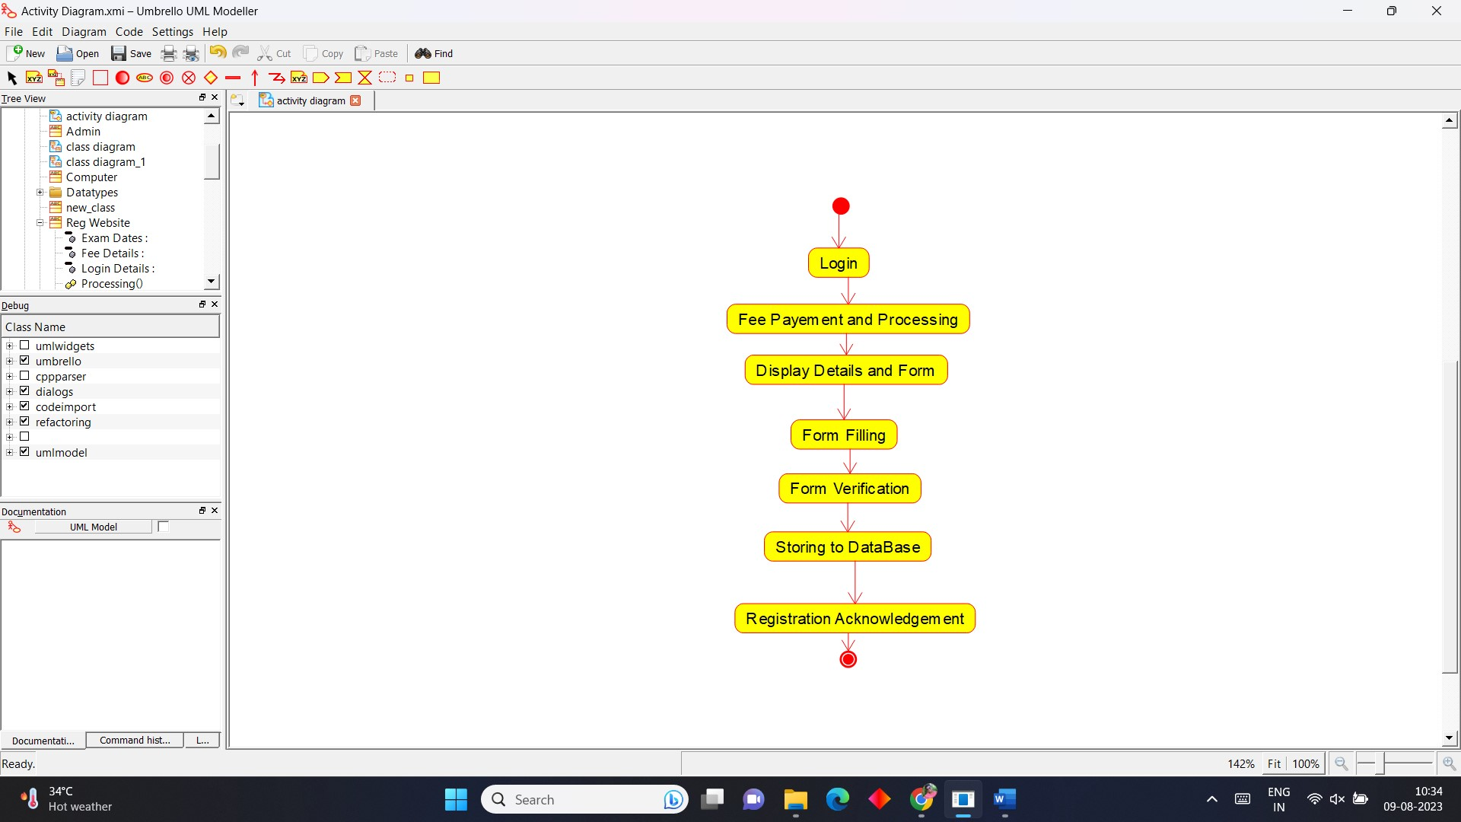

5.STATE DIAGRAM:

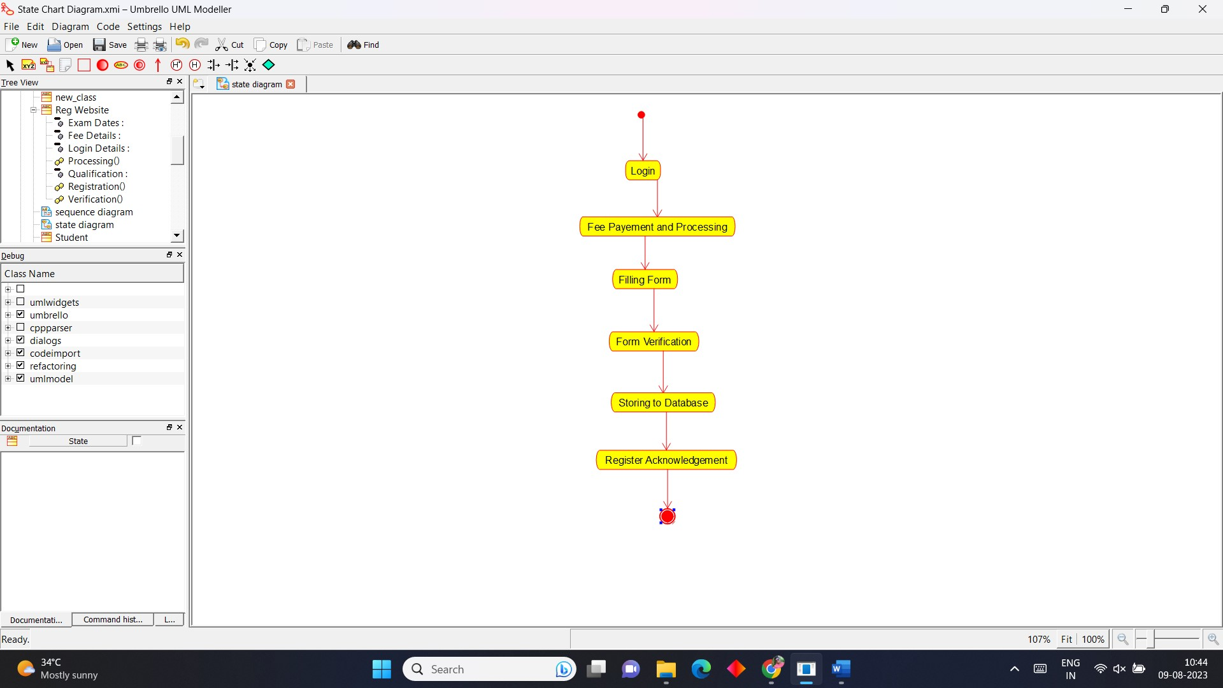

6.SEQUENCE DIAGRAM:

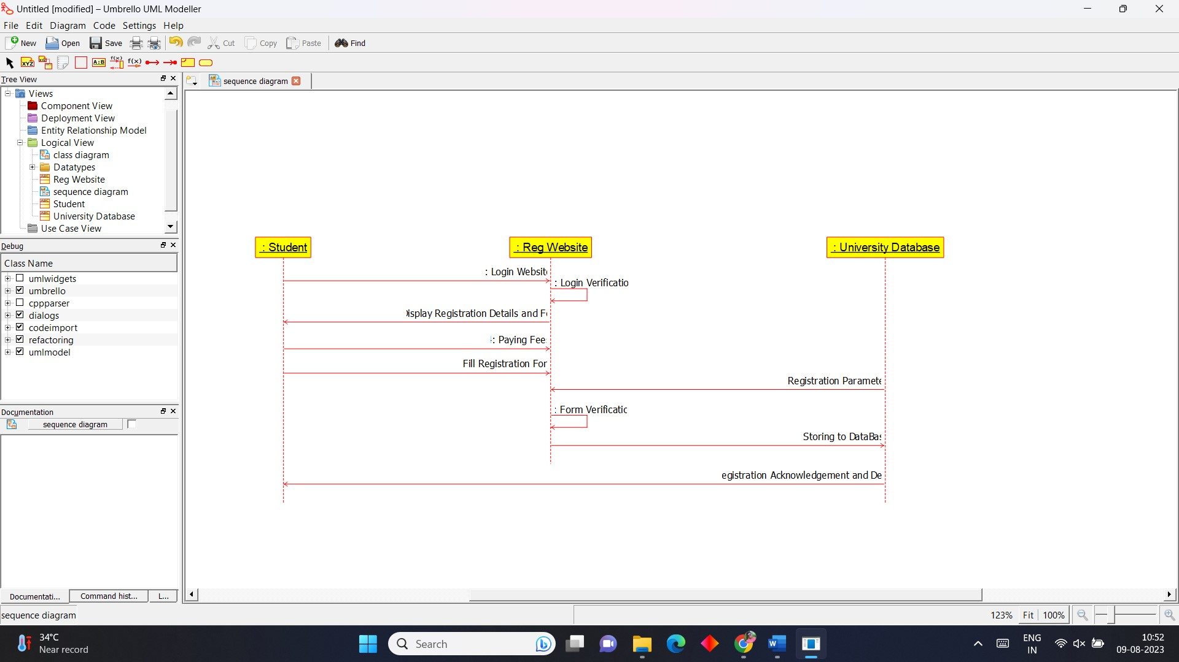

7. COLLABRATION DIAGRAM:

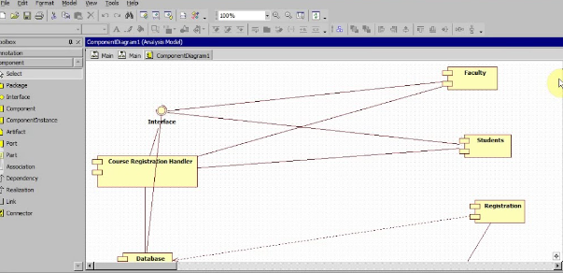

8. DEPLOYMENT DIAGRAM:

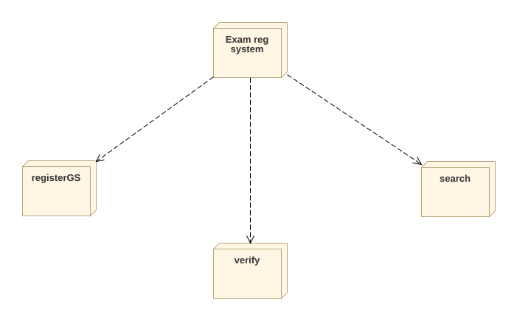

**4.** Develop a system using UML for implementing Stock Maintenance System. In this system, the customer can place orders and purchase items with the aid of the stock dealer and central stock system. These orders are verified and the items are delivered to the customer. Then the stock details are to be updated accordingly

**AIM:-**

To develop a system using UML for STOCK MAINTAINANCE SYSTEM.

UML DESIGNS:-

1.USECASE DIAGRAM:

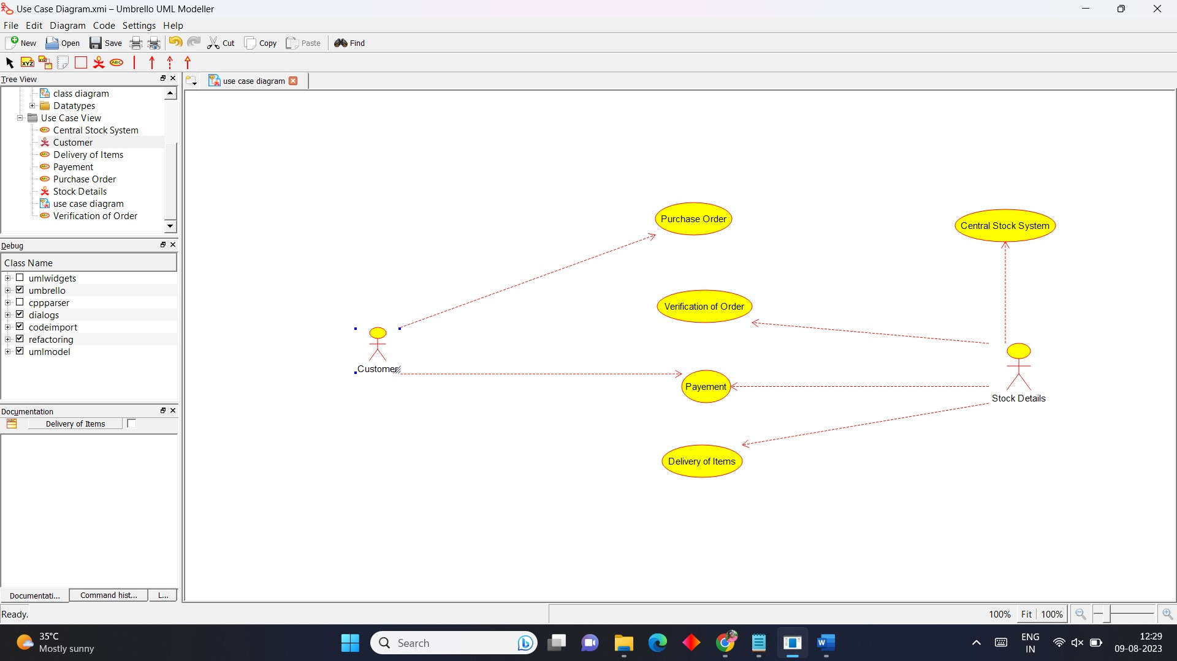

2.CLASS DIAGRAM:

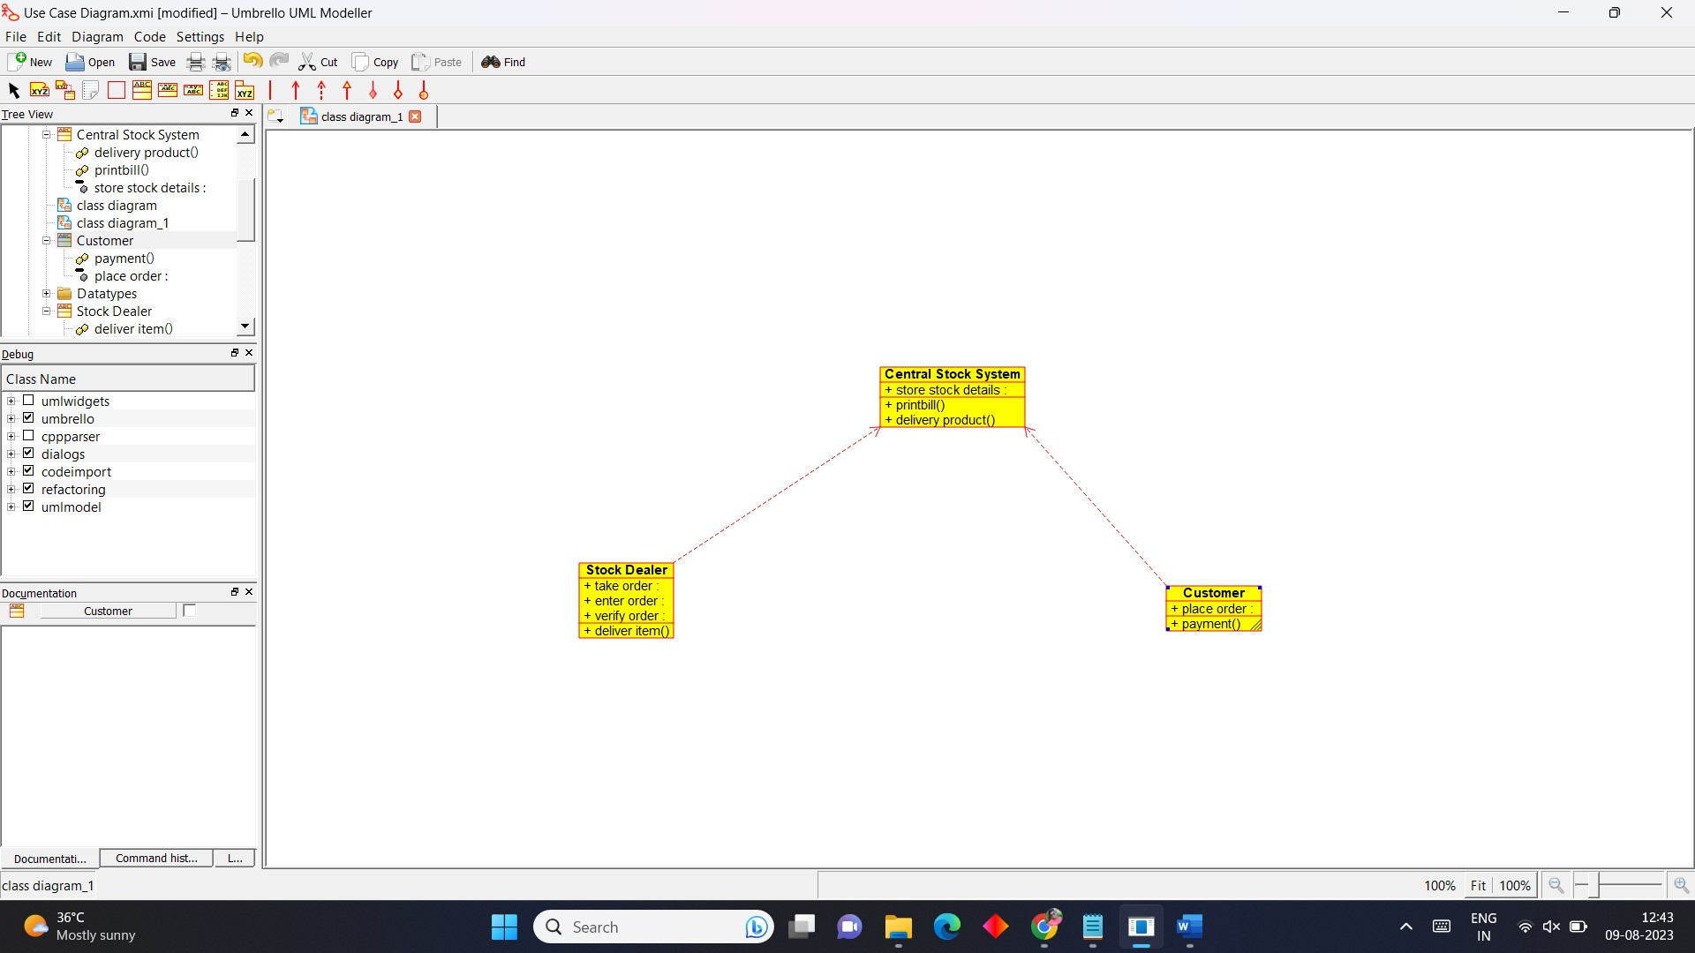

3.STATE DIAGRAM:

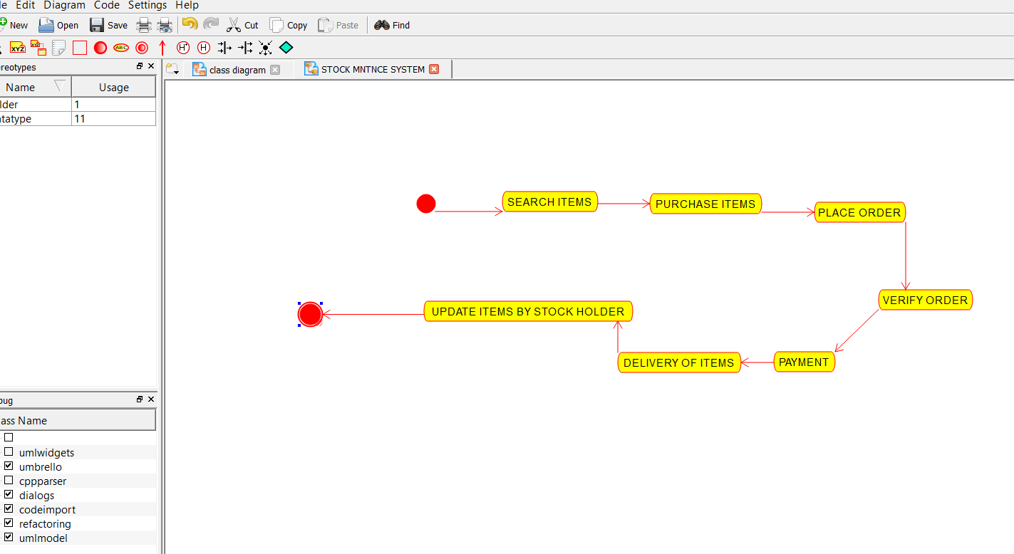

4.DEPLOYMENT DIAGRAM:

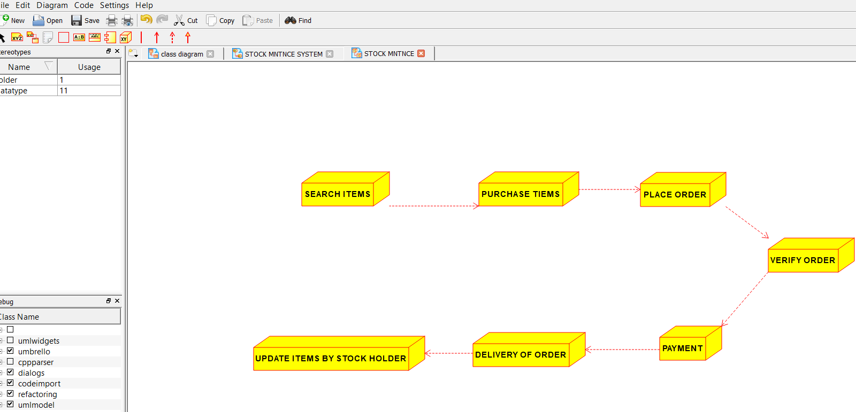

5.ACTIVITYDIAGRAM:

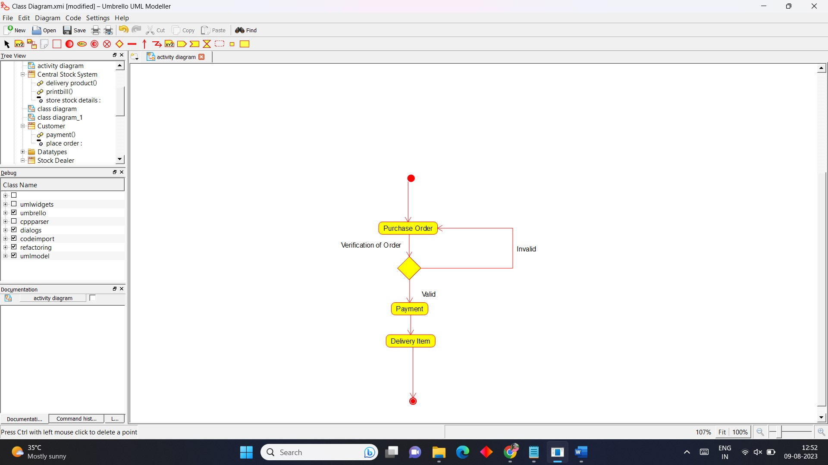

6.SEQUENCE DIAGRAM:

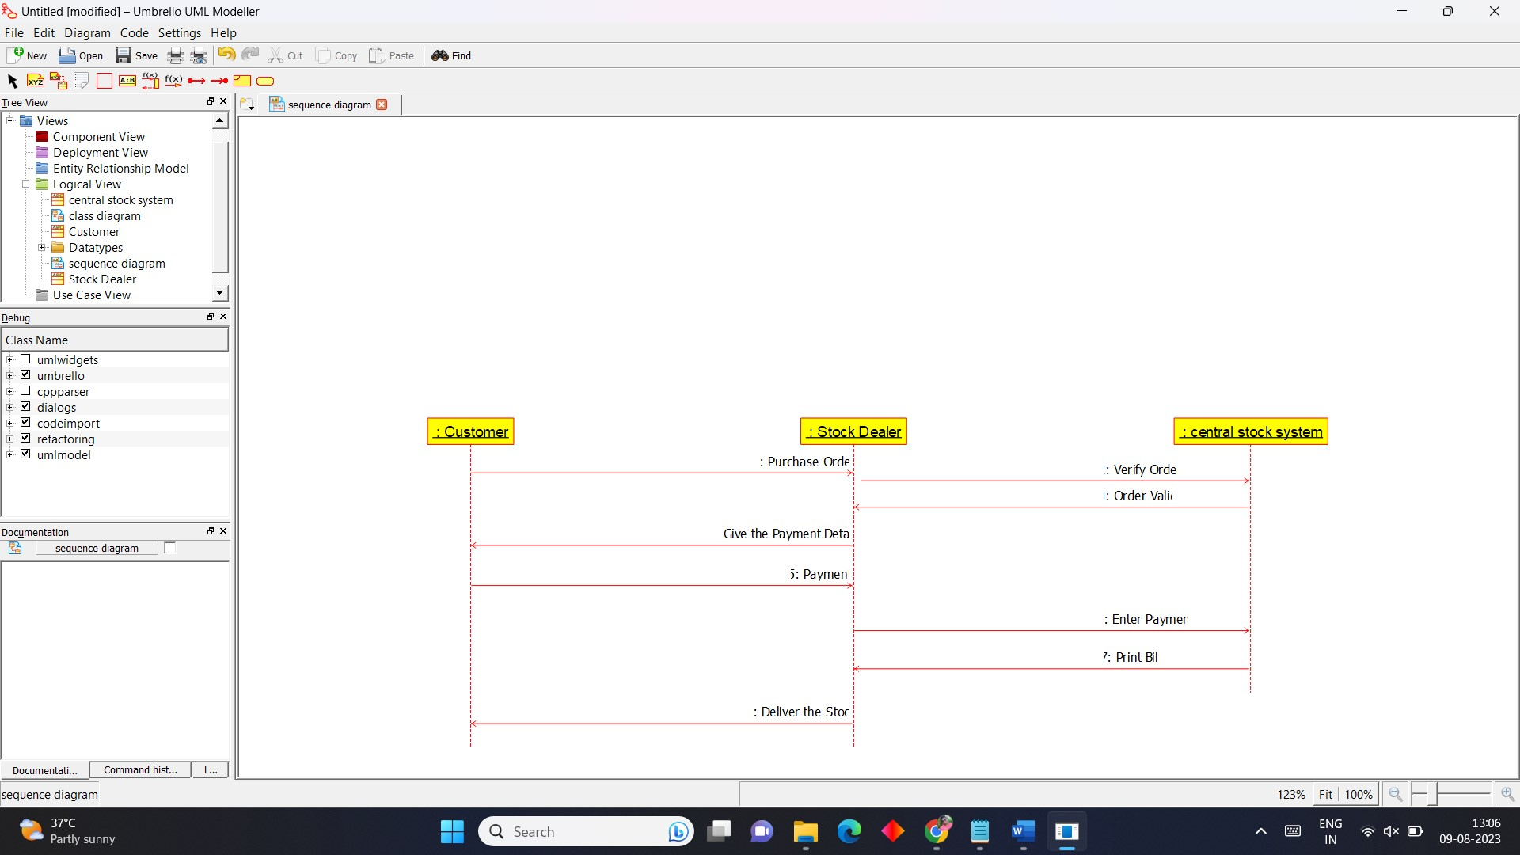

7.COLLABRATION DIAGRAM:

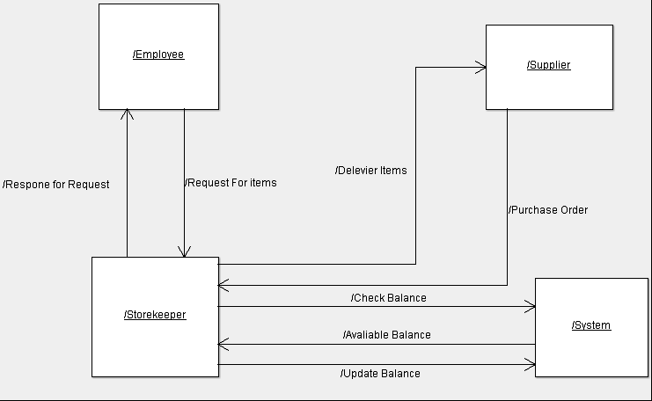

**5.** **Develop a system using UML for implementing Online Course Reservation System. This system is organized by the central management system. The student first browses and selects the desired course of their choice. The university then checks the availability of the seat if it is available the student is enrolled for the course.**

**AIM:-**

To develop a system using UML for ONLINE COURSE RESERVATION SYSTEM.

UML DESIGNS:-

1.COLLABORATION DIAGRAM:

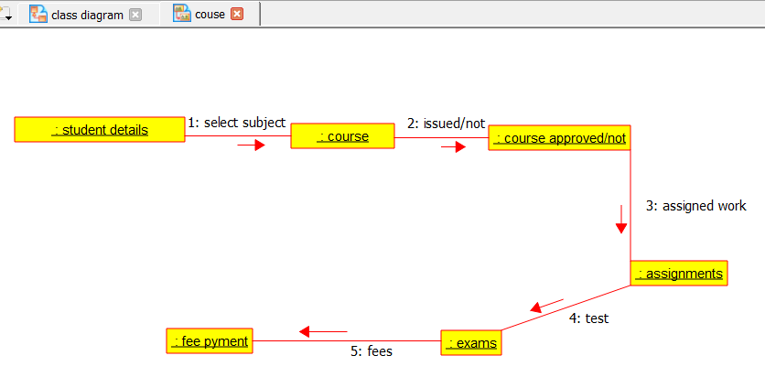

2.USECASE DIAGRAM: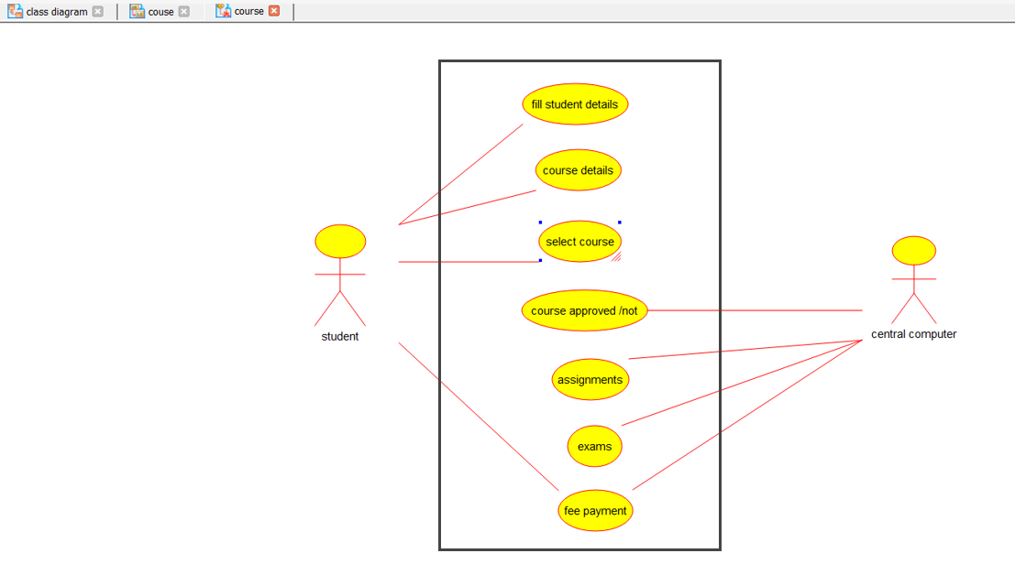

3.ACTIVITY DIAGRAM:

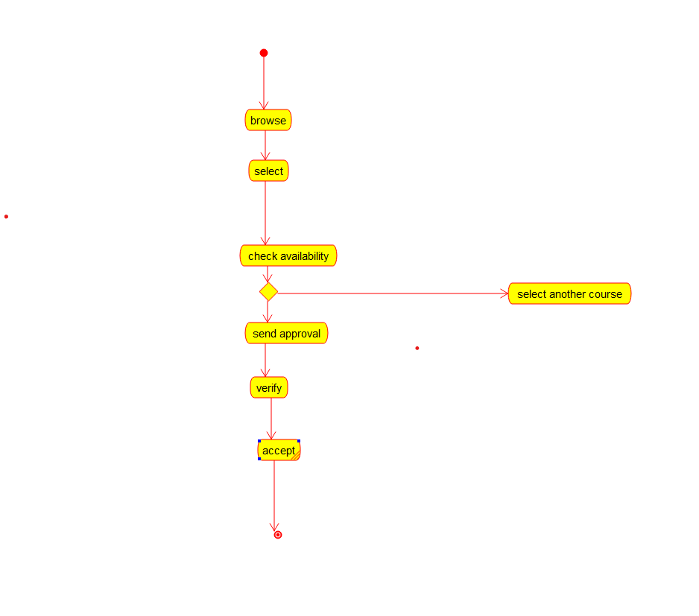

4.CLASS DIAGRAM:

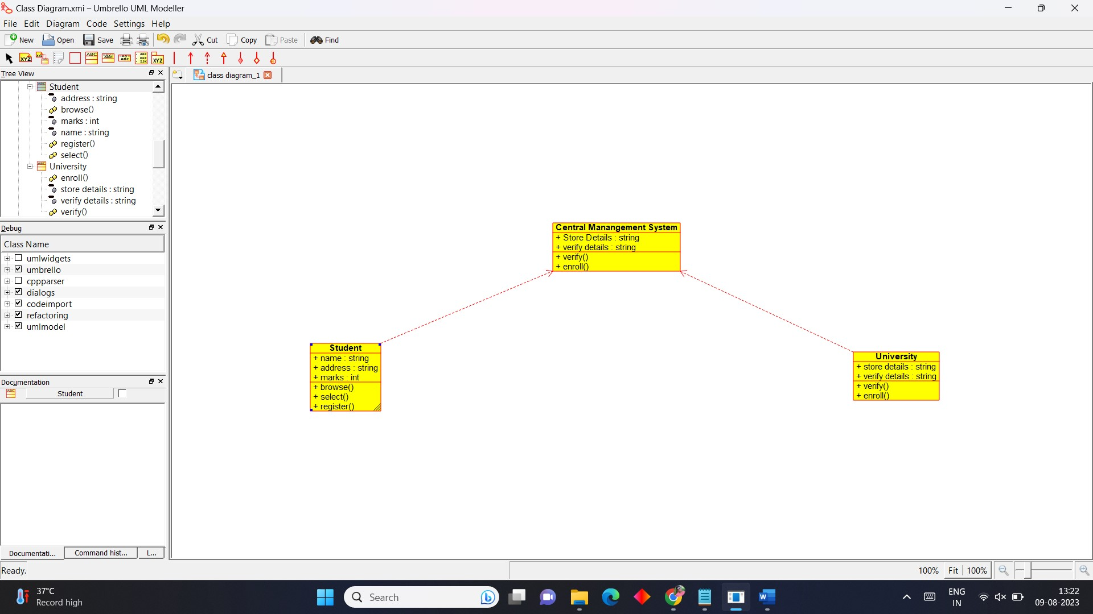

5.STATE DIAGRAM:

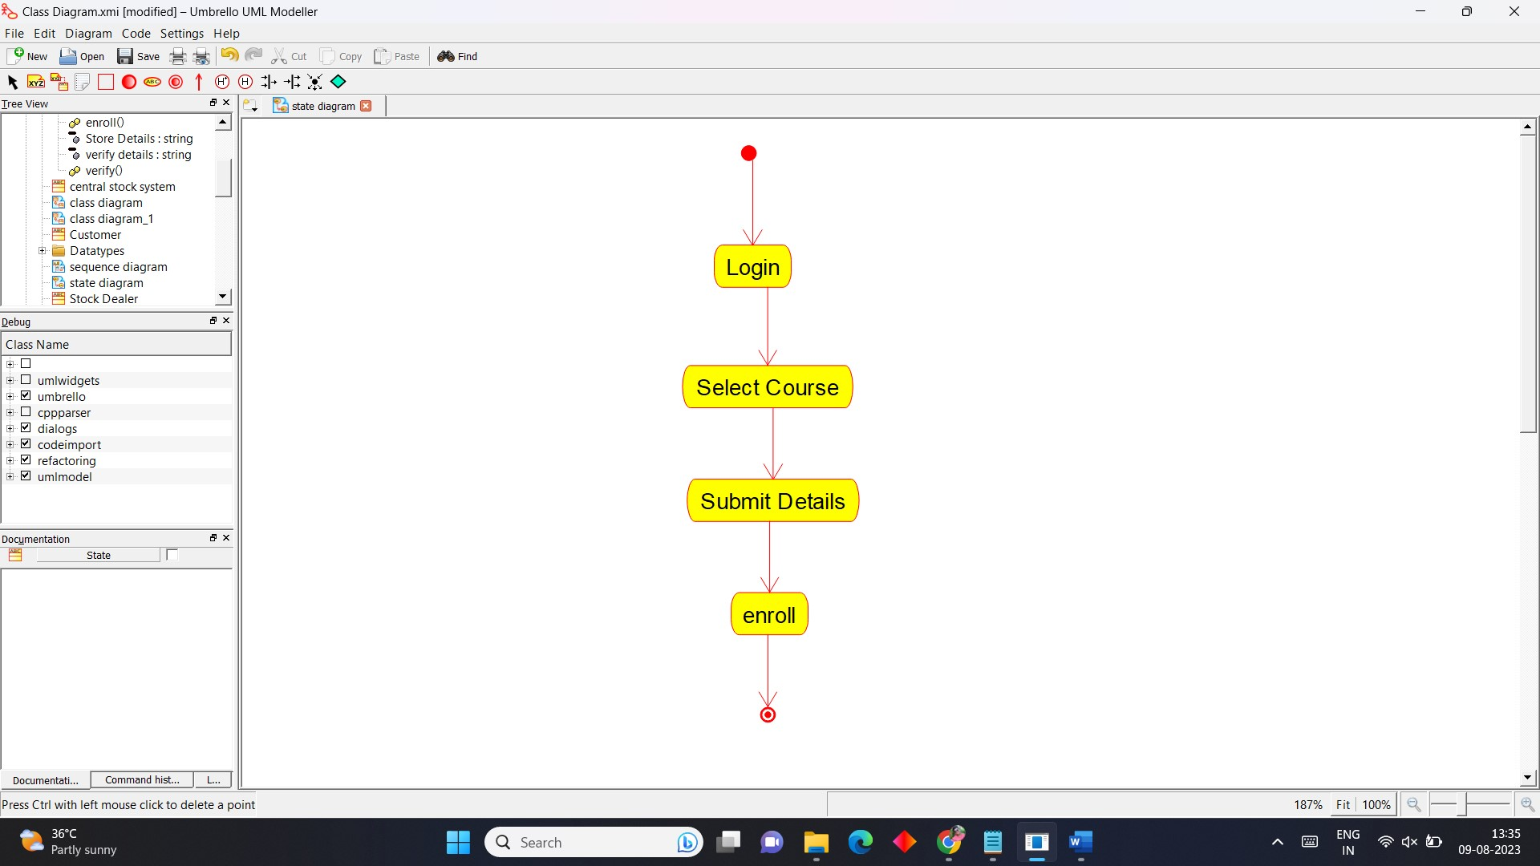

6.SEQUENCE DIAGRAM:

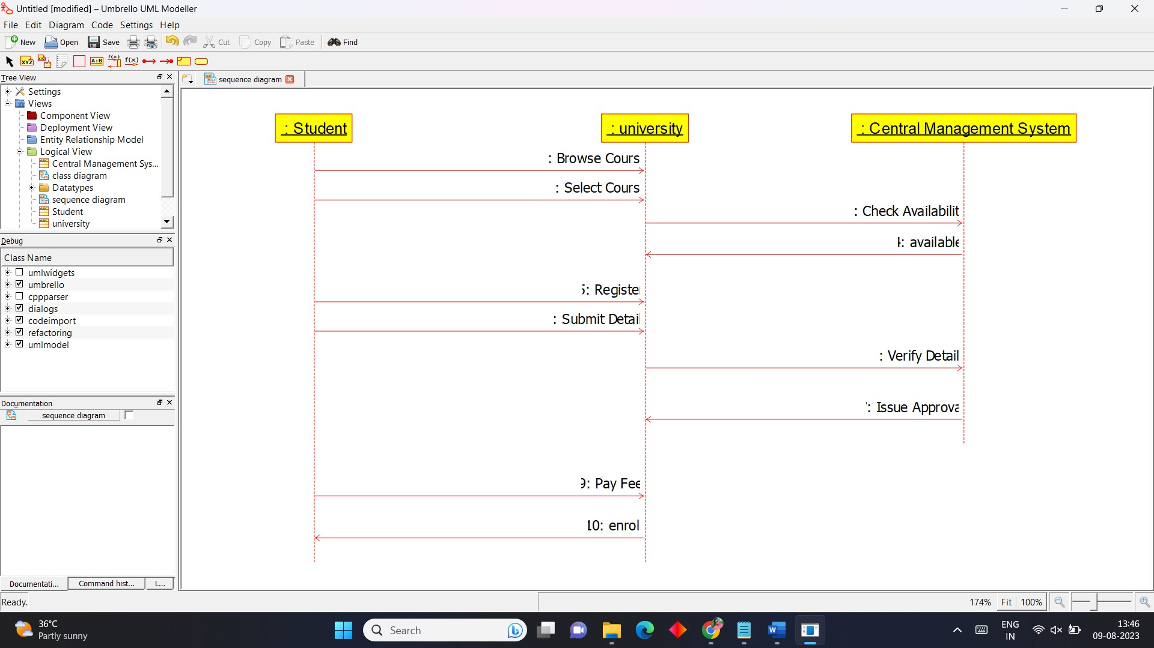

7.DEPLOYMENT DIAGRAM:

